**Phase 5: Apex Programming (Developer)**

**Goal of this Phase**

The goal of Phase 5 was to implement **Apex programming features** in Salesforce to support the Student Management System. This included creating **classes, triggers, SOQL/SOSL queries, collections, asynchronous processing, exception handling, and test classes** to ensure the application is efficient, scalable, and reliable.

**1. Classes & Objects**

* Created **StudentService** Apex class to handle business logic.
* Added methods for calculating student age based on Date of Birth and updating records.

**2. Apex Triggers (Before/After Insert/Update/Delete)**

* Implemented a **StudentTrigger** to:
  + Calculate Age before insert/update when Date of Birth is set.
  + Prevent invalid updates using before update triggers.
  + Maintain consistency when student records are deleted.

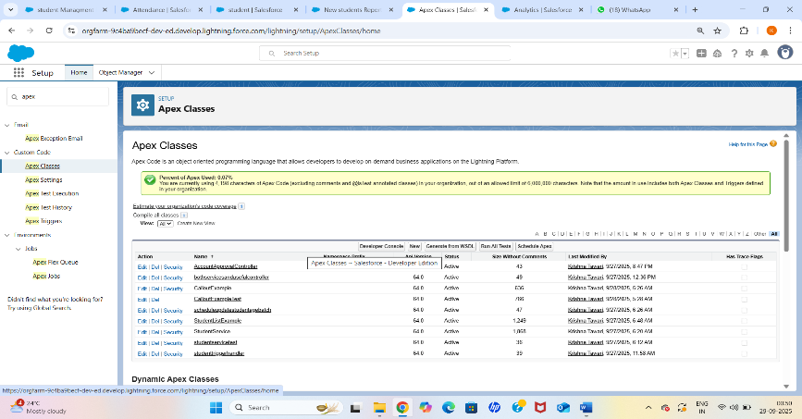

**3. Trigger Design Pattern**

* Applied **Handler Class Pattern**:
* Trigger delegates logic to StudentTriggerHandler class.
* Ensures clean separation of logic, reusable code, and easier maintenance.

**4. SOQL & SOSL**

* Used **SOQL queries** to fetch Student records with fields like Id, Date_of_Birth__c, and Age__c.
* Demonstrated **SOSL** for searching students by name across multiple fields.

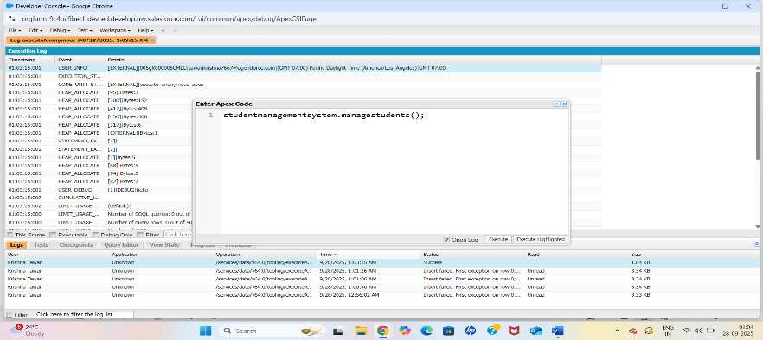

**5. Collections (List, Set, Map)**

* Used **List<Student__c>** for batch updates.
* Applied **Set<Id>** to handle unique record IDs.
* Implemented **Map<Id, Student__c>** to efficiently compare old and new trigger contexts.

**6. Control Statements**

* Used **If-Else conditions** for null checks.
* Applied **For loops** to process multiple student records.
* Incorporated **Try-Catch blocks** for exception handling.

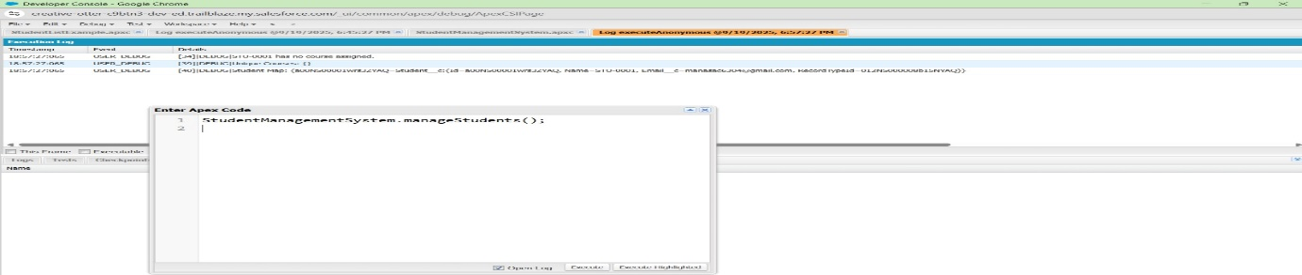

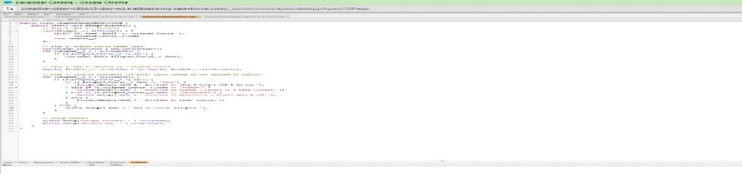

**7. Batch Apex**

* Created **UpdateStudentAgeBatch** class implementing Database.Batchable<SObject>.
* Processes students in batches to calculate and update Age.
* Scheduled and monitored using **Apex Jobs**.

**8. Queueable Apex**

* Developed **UpdateStudentAgeQueueable** class implementing Queueable.
* Allows background execution of student age updates.
* Can be chained for sequential execution.

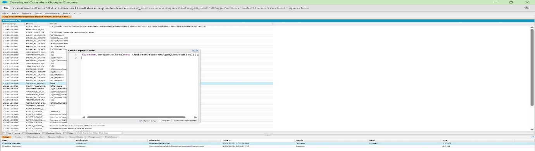

**9. Exception Handling**

* Wrapped logic in **try-catch** blocks.
* Handled null Date of Birth scenario to prevent runtime errors.
* Ensured no unhandled exceptions crash the system.

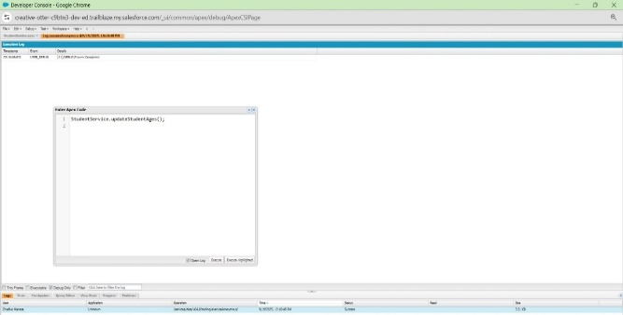

**10. Test Classes**

* Created **TestStudentService** and other test classes with @isTest.
* Verified Batch, Queueable, Future, and Exception Handling methods.
* Achieved **code coverage** and validated system reliability.

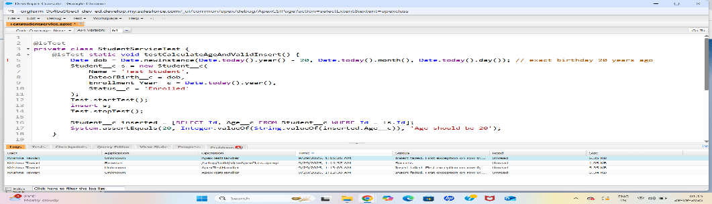

**11. Asynchronous Processing**

* Implemented and tested all four types: **Batch, Queueable, Scheduled, and Future Methods**.
* Verified job execution via **Apex Jobs** in Setup.
* Ensured scalability for handling large volumes of Student records.

